**Commands**

1. pwd: This command is used to print the path name of current working directory.

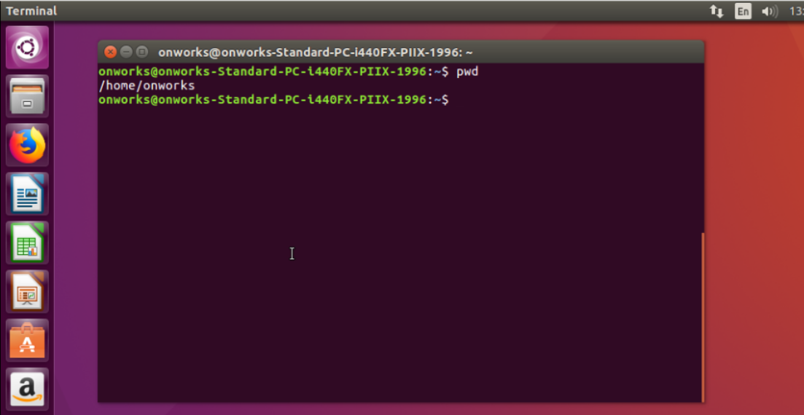

1. mkdir: This command is used to make directory. Here I have created directory as Sahana.

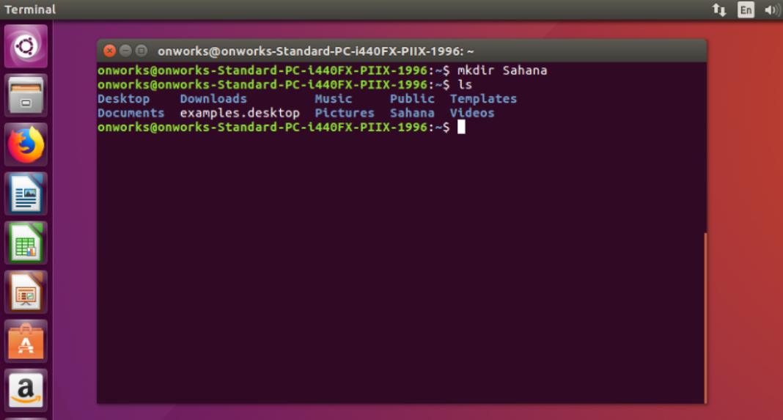

1. ls: This command is used to list the files in present working directory.

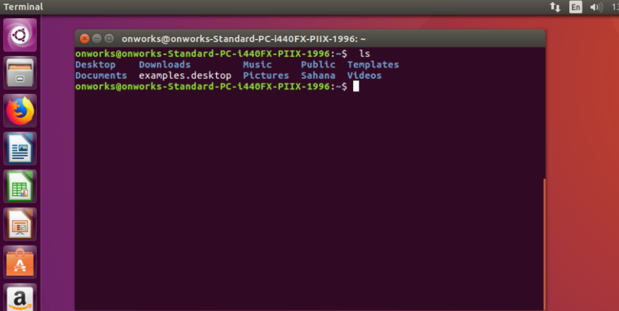

1. ls –a : This command is used to list the hidden files.

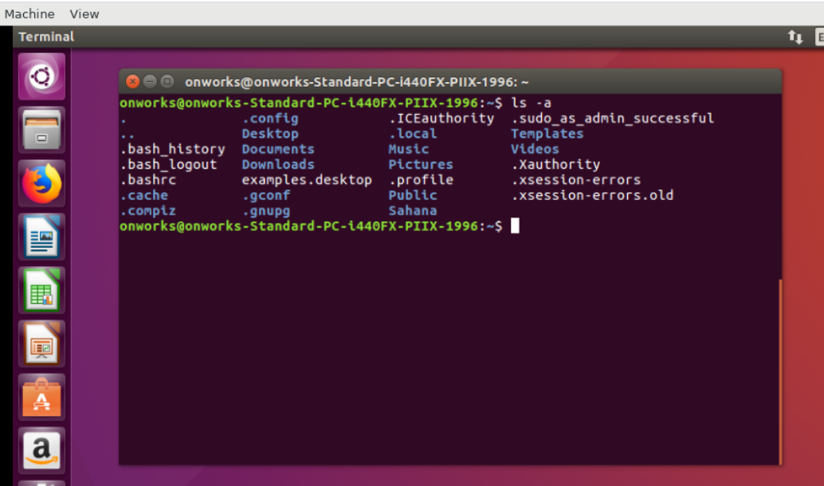

1. ls – l: This command is used to list files present in current working directory along with properties.

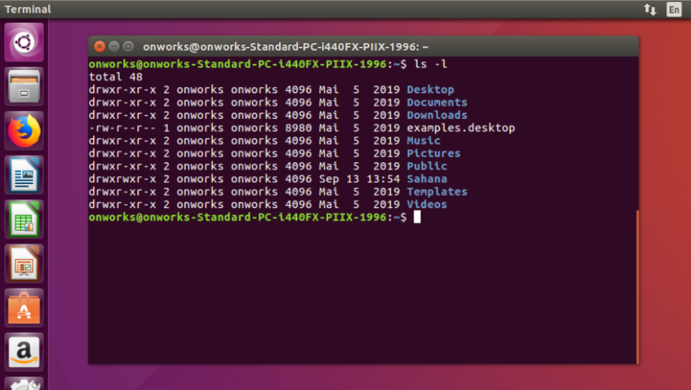

1. cd: Change directory command. This is used to change current working directory.

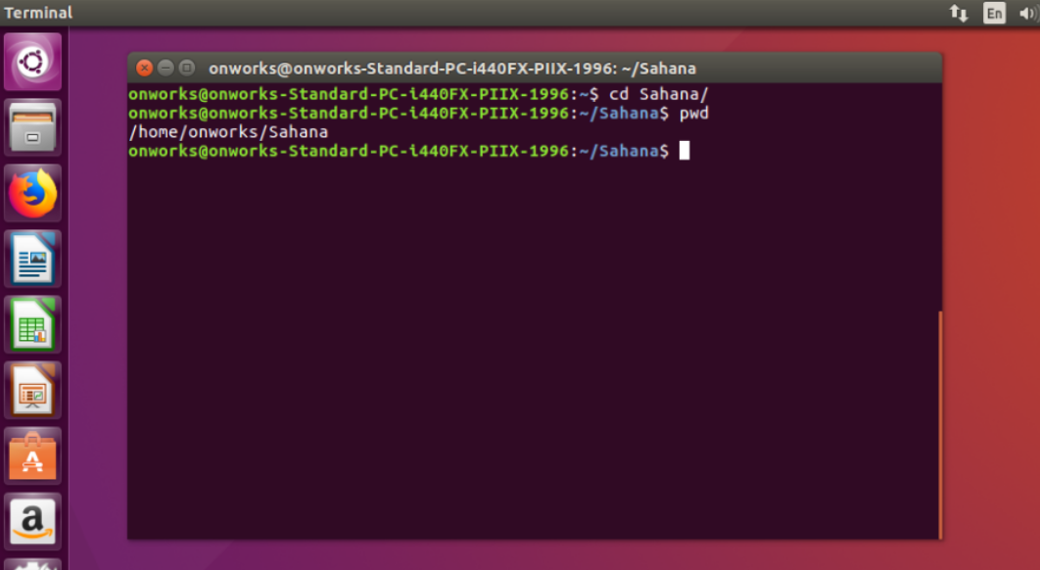

1. rm –R : This command is used to remove a directory.

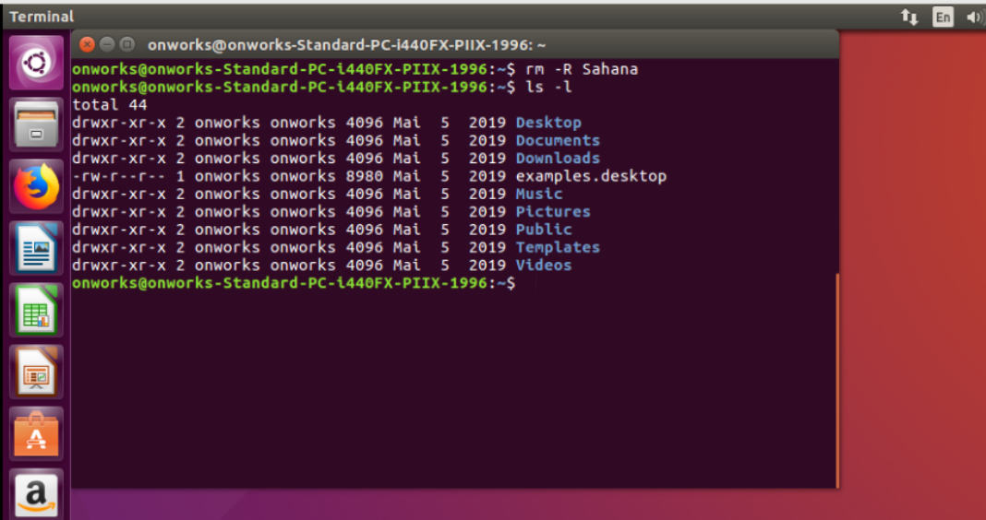

1. man: man command is used to display user manual of any command.

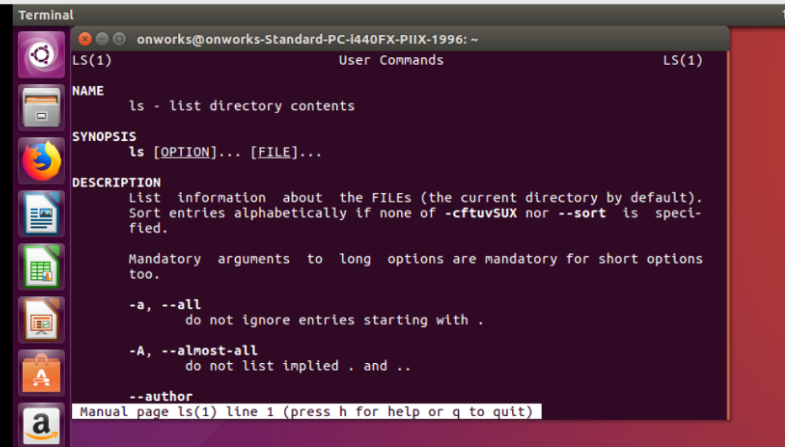

1. df: df command is used to display information related to file systems about total and available space.

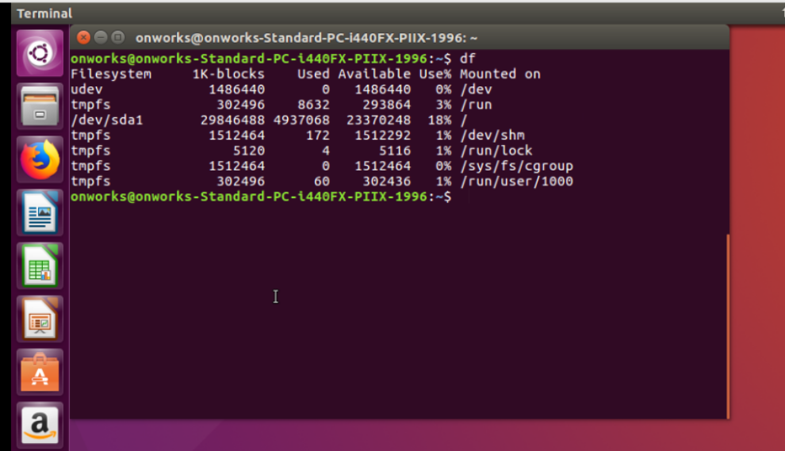

1. df –h : This command is used to display the size in terms of MB or GB.

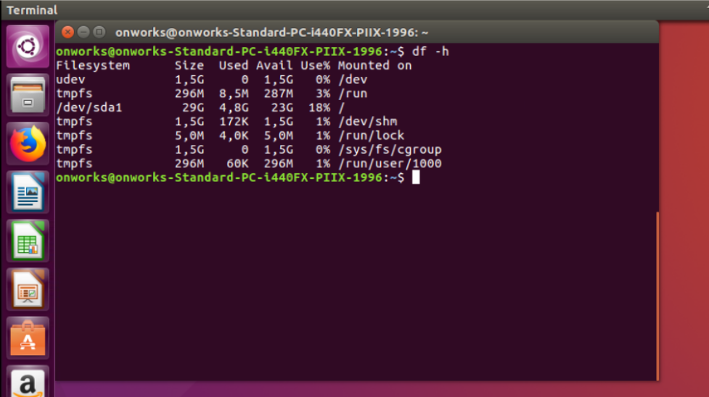

1. ps: This command is used to display the current running process and their PID’s.

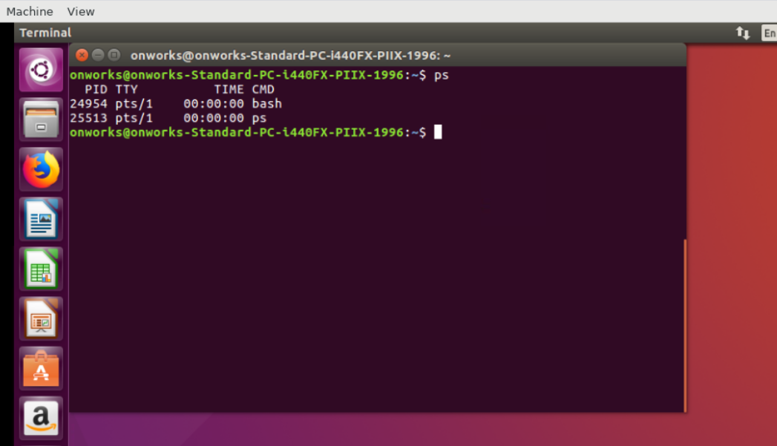

1. ps –a :This is option available with ps command.

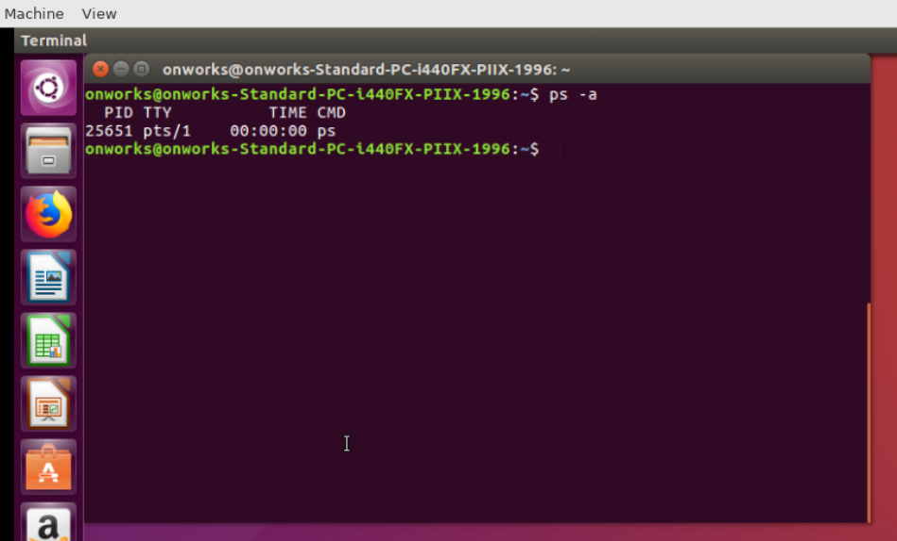

1. su, sudo : To change Super user privilege. This command is used to install new packages.

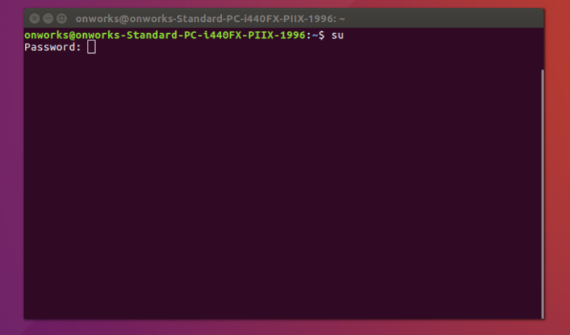

1. Kill: This command is used to kill the process.

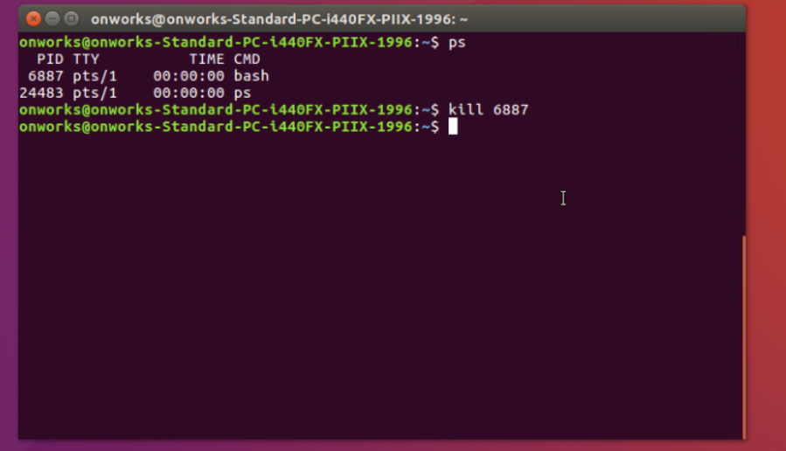

1. free : This command is used to give information about memory usage details.

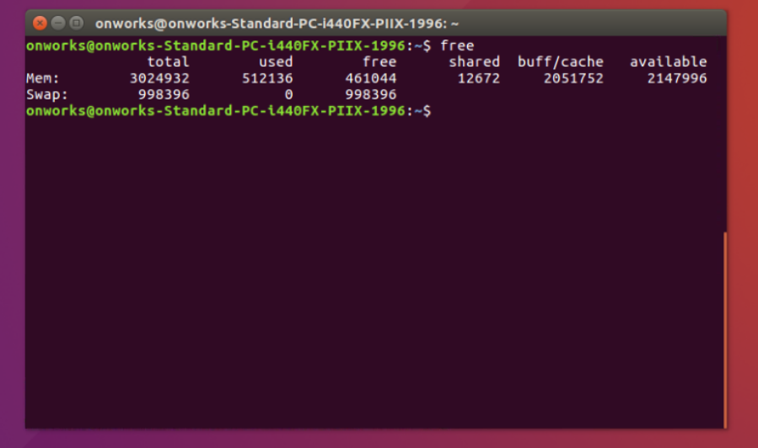

1. Free –h : This command is used to give information about memory usage details in GB or MB.

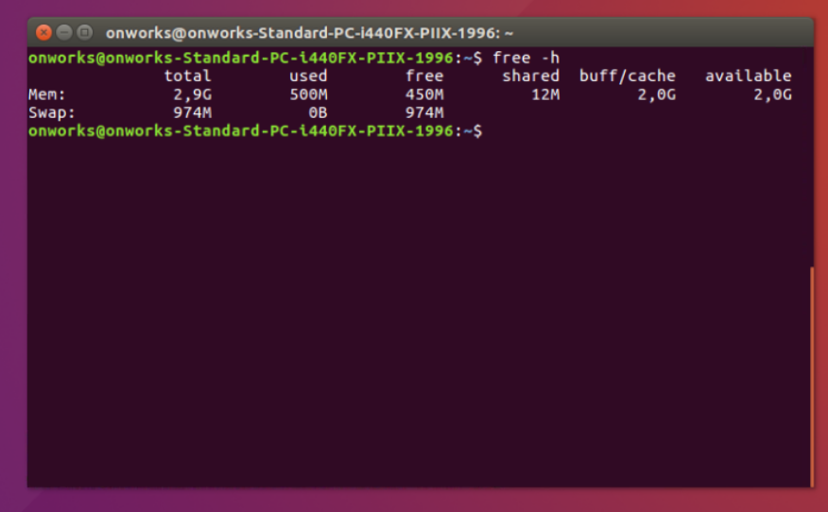

1. echo: To print or display the content on console.

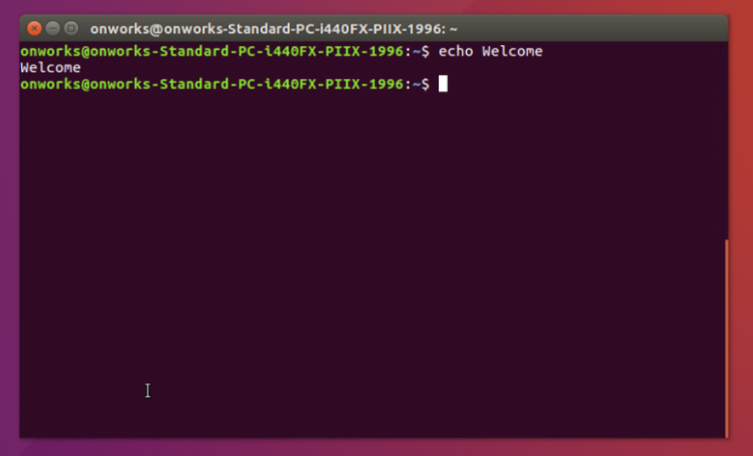

1. top: This command is used to list user and system process.

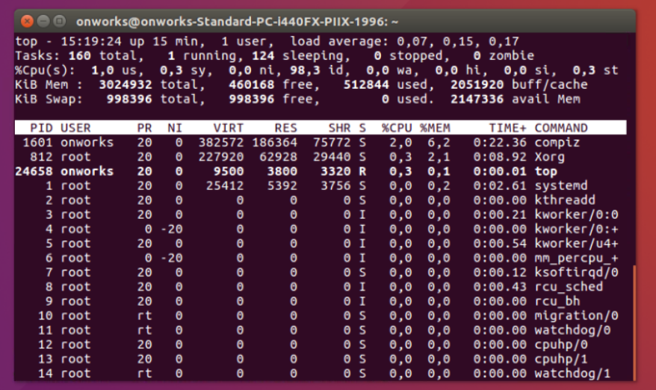

1. lscpu: This command gives information about CPU.

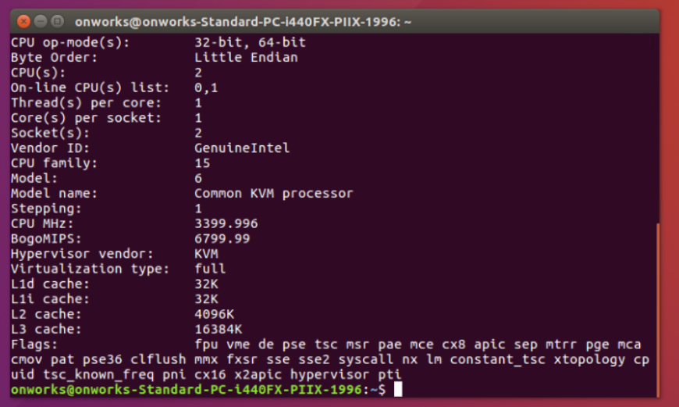

1. lsusb: This command is used to display information about USB buses and devices connected to them.

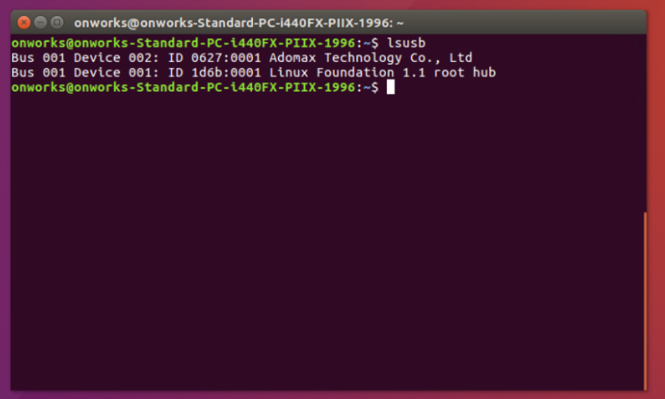

1. lshw: This command is used to list all system configuration.

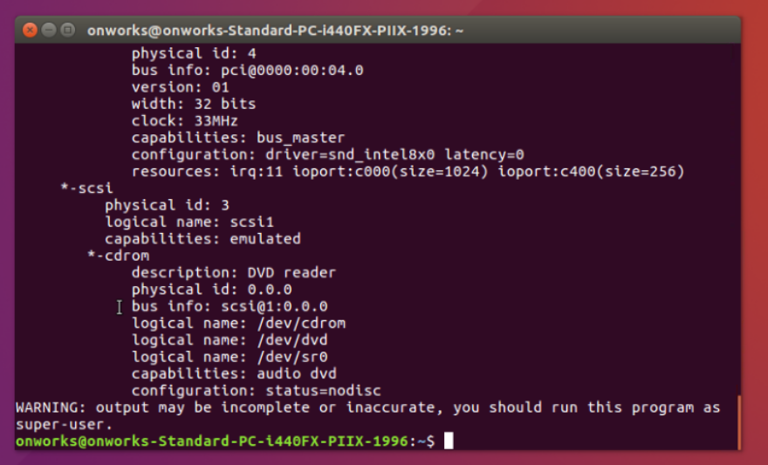

1. vi filename.txt: This command is used to create a new file.

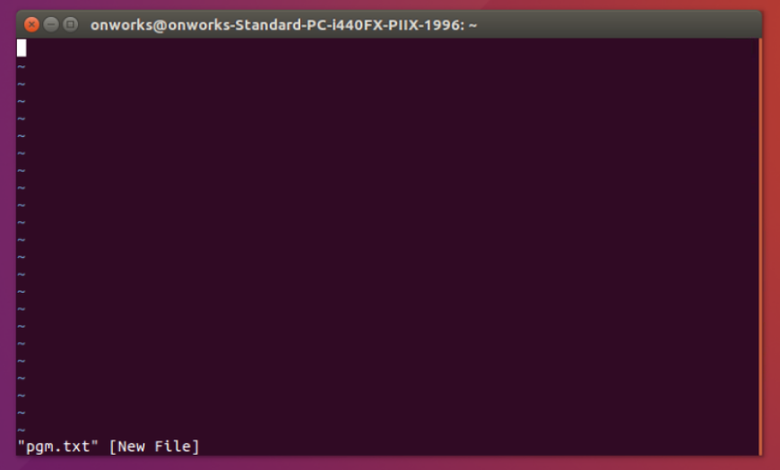

1. cat : This command is used to display the content of the file.

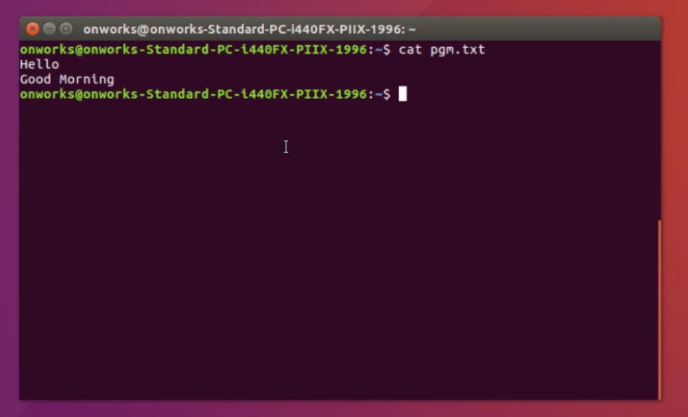

1. cp: This command is used to copy the content from source file to destination file.

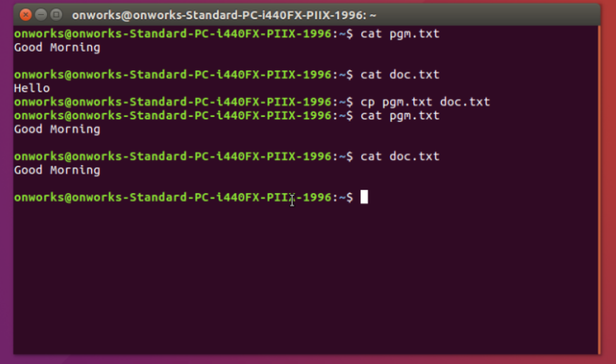

1. mv: This command is used to move the content from source file to destination file.

